VISVESVARAYA TECHNOLOGICAL UNIVERSITY
Jnana Sangama, Belagavi



Project Report on
“Blockchain Based Certificate Verification System”
In partial fulfillment of the requirements for the award of the Degree of
BACHELOR OF ENGINEERING
In
Computer Science and Engineering
By

Vishal Prasad Sharma (1AH21CS123)
Anayat Altaf Shah(1AH21CS127)
Raj Kumar(1AH21CS081)
Vandan Kumar M(1AH21CS117)

Under the guidance of
Mr. Panchaxari
Asst. Prof, Dept. of CSE
ACS COLLEGE OF ENGINEERING, Bangalore


DEPARTMENT OF COMPUTER SCIENCE AND ENGINEERING
ACS COLLEGE OF ENGINEERING
KAMBIPURA, MYSORE ROAD, BANGLORE-74
2024-2025

ACS COLLEGE OF ENGINEERING
KAMBIPURA, MYSORE ROAD, BANGLORE-74
Department of Computer Science and Engineering



Certificate

Certified that the Project Work entitled “Blockchain Based Certificate Verification System” is a bonafide work carried out by Mr. Vishal Prasad Sharma(1AH21CS123), Mr. Anayat Altaf Shah (1AH21CS127), Mr. Raj Kumar (1AH21CS081) and Mr. Vandan Kumar M (1AH21CS117) in partial fulfillment for the award of Bachelor of Engineering in Computer science & Engineering of the Visvesvaraya Technological University, Belgaum during the year 2024-2025. It is certified that all the corrections/suggestions indicated for internal assessment have been incorporated in the report deposited in the departmental library. The Project Report has been approved as it satisfies the academic requirements in respect of Project Work prescribed for the said degree.

-

Signature of Guide Signature of Project Signature of HOD

Coordinator

Mr. Panchaxari Ms. Laxmi Priya Dr. T. Senthil Kumaran Asst Professor, CSE Asst Professor, CSE Professor & HOD, CSE
ACSCE, Bangalore ACSCE, Bangalore ACSCE, Bangalore

External Viva:
Name of the Examiner Signature with Date

ACS COLLEGE OF ENGINEERING
KAMBIPURA, MYSORE ROAD, BANGLORE-74



DECLARATION

We, Mr. Vishal Prasad Sharma(1AH21CS123), Mr. Anayat Altaf Shah (1AH21CS127), Mr. Raj Kumar (1AH21CS081) and Mr. Vandan Kumar M (1AH21CS117), hereby declare that the project work entitled “Title of the Project” has been independently carried out by us under the guidance of Dr./Prof./Mr./Mrs. Name of the Guide, Designation, Department of Computer Science & Engineering, ACS College of Engineering, Bangalore, in partial fulfillment of the requirements of the degree of Bachelor of Engineering in Computer Science & Engineering of Visvesvaraya Technological University, Belgaum.
We further declare that we have not submitted this report either in part of in full to any other university for the reward of any degree.

Vishal Prasad Sharma(1AH21CS123)
Anayat Altaf Shah(1AH21CS127)
Raj Kumar(1AH21CS081)
Vandan Kumar M(1AH21CS117)

Place: Bengaluru
Date:
ABSTRACT
The proliferation of digital certificates and credentials has given rise to concerns surrounding authenticity, fraud, and the complexities of manual verification processes. Traditional centralized systems are vulnerable to single points of failure, data tampering, and lack of transparency. This application proposes a blockchain-based solution to address these challenges by leveraging the immutable, decentralized, and transparent nature of distributed ledger technology.
The proposed system comprises three main components: a user-friendly interface for certificate submission, integration with a blockchain network for secure data storage and hash generation, and a web page dedicated to certificate verification. Users can submit their digital certificates and relevant details through an intuitive interface, which generates a unique cryptographic hash value representing the certificate's contents.
This hash value is recorded on a blockchain network, ensuring its immutability and resistance to tampering. To facilitate efficient verification, the hash value is encoded into a QR code associated with the certificate. During the verification process, users can scan or upload the QR code, which is decoded to extract the hash value. The system queries the blockchain to retrieve the recorded hash and compares it with the extracted value. If the hash values match, the certificate is deemed authentic and valid. However, if a mismatch occurs, it indicates potential tampering, and the certificate is flagged as invalid.
The system adheres to security, performance, and usability best practices, ensuring a seamless user experience. It is designed to be scalable, interoperable, and promotes broader adoption across educational institutions and professional organizations globally. By leveraging blockchain's inherent advantages, this system establishes a trusted, transparent, and tamper evident framework for digital certificate verification, reducing fraud and enhancing the credibility of academic and professional credentials.

ACKNOWLEDGEMENT

I take this opportunity to express my sincere gratitude and respect to the ACS College of Engineering, Bengaluru for providing me an opportunity to carry out Internship report.

I express my deep regards to my honorable chairman Sri Dr. A.C. Shanmugam for providing me an opportunity to fulfil my ambition in this prestige institute.

I would like to express my immense gratitude to Dr. Anandthirtha.B. Gudi, Principal, ACS College of Engineering, Bengaluru, for his timely help and inspiration during the tenure of the course.

I express my sincere regards and thanks to Dr. T Senthil Kumaran, Professor & HOD, Computer Science and Engineering, ACSCE, Bengaluru for the encouragement and support throughout the work.

I hereby like to thank our Project Coordinator express Ms. LaxmiPriya, Assistant Professor, Computer Science and Engineering, ACSCE, Bengaluru for the encouragement and support throughout the work.

I am highly thankful to our guide Mr. Panchaxari, Assistant Professor, Computer Science and Engineering, ACSCE, Bengaluru for giving me a valuable suggestion, providing cooperation and moral support towards completion of Mini Project Work.

Vishal Prasad Sharma(1AH21CS123)
Anayat Altaf Shah(1AH21CS127)
Raj Kumar(1AH21CS081)
Vandan Kumar M(1AH21CS117)

TABLE OF CONTENTS
CHAPTER 1
INTRODUCTION
1.1 Introduction
1.2 Areas of your project
1.3 Challenges and Complexities in your project
1.4 Motivation
1.5 Objectives
1.6 Problem Statement
1.7 Applications
1.8 Summary

CHAPTER 2
LITERATURE SURVEY
2.1 Introduction
2.2 Background Study
2.3 Existing Model
2.4 Summary

CHAPTER 3
REQUIREMENT ANALYSIS
3.1 Introduction
3.2 System Requirements
3.2.1 Hardware Requirements
3.2.2 Software Requirements
3.3 Summary

CHAPTER 4
PROPOSED SYSTEM
4.1 Introduction
4.2 Proposed Model
4.3 Detailed Description of Sub Models
E.g. 4.3.1 Pre-Processing Module
4.3.2 Feature Extraction Module
4.3.3 Classification
4.3.4 Training and Validation
4.4 Data Flow Diagram (DFD)
E.g. 4.4.1: Level 0 DFD
4.4.2: Level 1 DFD
4.4.3: Level 2 DFD
4.5 Sequence Diagram
4.6 Summary

CHAPTER 1
INTRODUCTION
1.1 Introduction
Blockchain technology has emerged as a revolutionary force, disrupting various industries and offering unprecedented levels of transparency, security, and decentralization. In the realm of digital certificates, blockchain-based verification systems have gained significant traction, addressing long-standing challenges like fraud, counterfeiting, and authenticity concerns. Traditional methods of issuing and verifying certificates often rely on centralized databases, which are susceptible to hacking, complex verification processes, and human error. These limitations necessitate a more secure, efficient, and trustworthy system—one that blockchain technology can provide.
A blockchain-based certificate verification system leverages the strengths of distributed ledger technology to ensure the immutability and transparency of recorded data. Each digital certificate is assigned a unique hash value, serving as a digital fingerprint that captures the certificate’s content and metadata. This hash value is then stored on the blockchain, making any attempt to alter or tamper with the certificate immediately detectable through a mismatch of hash values.
The decentralized nature of blockchain eliminates the need for a central authority, reducing the risk of a single point of failure and enhancing overall system security. Furthermore, the integration of QR codes into the verification process simplifies accessibility and usability. By scanning a QR code associated with a certificate, users can seamlessly initiate the verification process, comparing the stored hash with the current certificate’s hash to confirm its authenticity.
1.2 Areas of the Project
- Certificate Issuance: Generating unique digital certificates with metadata and content.
- Hashing Process: Creating a unique hash value for each certificate.
- Blockchain Integration: Storing the hash value on a decentralized blockchain network.
- QR Code Generation: Encoding the hash value into a QR code.
- Verification System: Matching the current certificate’s hash with the stored hash.
- User Interface: Providing an accessible and user-friendly platform for verification.
1.3 Challenges and Complexities in the Project
- Ensuring data immutability and integrity.
- Managing efficient and scalable blockchain storage.
- Implementing fast and accurate hash comparisons.
- Simplifying the verification process for non-technical users.
- Addressing potential blockchain network fees and transaction speeds.
- Maintaining security while ensuring ease of use.
1.4 Motivation
The increasing prevalence of fraudulent certificates and the complexities of traditional verification methods highlight the need for a more secure and efficient system. Blockchain’s ability to provide a decentralized, tamper-proof ledger offers a compelling solution to these issues. By integrating QR codes and user-friendly interfaces, this project aims to simplify and streamline certificate verification while maintaining high levels of security and trust.
1.5 Objectives
- Develop a blockchain-based certificate verification system.
- Ensure the authenticity and integrity of digital certificates.
- Eliminate the risk of centralized database vulnerabilities.
- Provide a simple, accessible verification process via QR codes.
- Enhance security, transparency, and efficiency.
1.6 Problem Statement
Traditional digital certificate verification systems suffer from security vulnerabilities, centralized points of failure, and complex verification processes. This project aims to develop a blockchain-based system that ensures the authenticity, integrity, and transparency of digital certificates while simplifying the verification process.
1.7 Applications
- Educational institutions issuing degrees and certifications.
- Professional organizations providing accreditations.
- Government agencies verifying official documents.
- Corporate HR departments validating employee credentials.
1.8 Summary
Blockchain-based certificate verification systems offer a robust framework for establishing trust, transparency, and authenticity in digital credentials. By leveraging distributed ledger technology, unique hash values, and QR code integration, this approach enhances security, simplifies the verification process, and reduces the risk of fraud and counterfeiting.

CHAPTER 2
LITERATURE SURVEY
2.1 Introduction
Blockchain technology has a wide range of applications across various fields, including education, engineering, administration, medicine, elections, construction, and e-government. This research primarily focuses on the education sector, where blockchain is being increasingly adopted to address challenges related to certificate verification, fraud prevention, and data integrity. This section reviews existing research and case studies that highlight the use of blockchain technology in the education domain.
2.2 Background Study
In the 21st century, the rapid production of data across industries has introduced challenges in data collection, storage, and analysis. Blockchain technology, with its decentralized and immutable nature, offers a robust solution to these challenges. In the education sector, blockchain is being used to issue and verify academic credentials, digital badges, and certifications, ensuring transparency and reducing the risk of fraud.
2.3 Existing Model
- European Data Science Academy (EDSA):
  - EDSA utilizes blockchain technology to provide data science skills and certifications to job seekers.
  - It also offers training programs to develop a new generation of world-leading data scientists.
  - The system addresses challenges related to data collection, storage, and analysis in the digital age.
- Certificate Validation Using Blockchain (Gayathiri et al., 2023):
  - This paper proposes a blockchain-based system for certificate validation to address issues like certificate forgery and manual verification challenges.
  - It highlights the immutable and decentralized nature of blockchains, which ensures transparency and tamper-resistance.
- Award Badging and Validation Method (Fouzia et al., 2024):
  - Focuses on using blockchain for validating digital badges or micro-credentials awarded for skills, achievements, or certifications.
  - Argues that blockchain transparency can overcome challenges in traditional badging systems, such as centralization and lack of trusted verification.
- Blockchain-Based Certificate Verification (Min Choi et al.):
  - The system generates an electronic file of a paper certificate and calculates its hash value.
  - The hash value is stored in the blockchain, and a QR code is generated for verification.
  - Users can verify the authenticity of the certificate through mobile phone scanning or website inquiries.
  - The unmodifiable properties of blockchain enhance the credibility of certificates and reduce the risk of loss or tampering.
- Blockchain Internals and Digital Signatures (Hongning Dai et al.):
  - Explains the structure of blockchain, including blocks, hashes, and the genesis block.
  - Describes the use of private and public keys for signing and verifying transactions.
  - Highlights the two phases of digital signatures: signing and verification.
- Digitalization of Certificates (Gayatri et al.):
  - Discusses the challenges faced by students and institutions in maintaining and validating academic certificates.
  - Proposes a blockchain-based system to store certificates securely.
  - Uses a chaotic algorithm to generate hash values for certificates, which are then stored on the blockchain.

- Microsoft Certification Badges:
  - Microsoft partnered with Pearson VUE’s Acclaim platform to issue blockchain-based certification badges.
  - These badges provide detailed information about the certification holder’s skills and achievements.
  - Benefits include easy sharing of certifications, identification of job opportunities, and salary expectations based on certified skills.
2.4 Summary
The literature survey highlights the growing adoption of blockchain technology in the education sector to address challenges related to certificate verification, fraud prevention, and data integrity. Existing models demonstrate the effectiveness of blockchain in ensuring transparency, immutability, and security in the issuance and validation of digital credentials. These systems leverage cryptographic hashing, QR codes, and decentralized ledgers to provide tamper-proof and user-friendly solutions for certificate management and verification.

CHAPTER 3
REQUIREMENT ANALYSIS
3.1 Introduction
The requirement analysis phase is crucial for understanding the scope, functionality, and constraints of the Blockchain-Based Certificate Verification System. This system is designed as a standalone desktop application that enables secure, tamper-proof issuance, verification, and management of educational certificates using blockchain technology. The application ensures data integrity, security, and ease of access without requiring an internet connection.
The system provides three core functionalities:
- Certificate Issuance and Registration: Securely issue and register certificates on the blockchain.
- Certificate Verification: Allow users to verify certificate authenticity through manual input or QR code scanning.
- Certificate Management and Revocation: Enable authorized institutions to manage and update certificate records when necessary.
This chapter outlines the system’s hardware and software requirements, performance expectations, and design constraints to ensure the development of a robust and efficient application.
3.2 System Requirements
3.2.1 Hardware Requirements
- Processor: Intel Core i3 or higher
- Memory: Minimum 4GB RAM (recommended for optimal performance)
- Storage: Sufficient disk space for application and datasets
3.2.2 Software Requirements
- Operating System: Windows, macOS, Linux
- Programming Language: Python 3.9
- Dependencies:
  - PyQt5: For building the graphical user interface (GUI)
  - Blockchain: For creating data blocks and generating unique hash values
  - Qrcode: For generating QR codes associated with hash values
3.3 Summary
This chapter describes the essential hardware and software requirements for the Blockchain-Based Certificate Verification System. The system is designed for cross-platform compatibility and provides a user-friendly interface for secure certificate handling. It leverages blockchain technology to ensure data security and integrity, offering a scalable and efficient solution for certificate management.

CHAPTER 4
PROPOSED SYSTEM
4.1 Introduction
The proposed system is a blockchain-based certificate verification system designed to address the challenges of fraud, counterfeiting, and inefficiencies in traditional certificate verification methods. By leveraging blockchain technology, the system ensures the authenticity, integrity, and transparency of digital certificates. This chapter provides an overview of the proposed model, detailed descriptions of sub-modules, data flow diagrams, and sequence diagrams.
4.2 Proposed Model
The proposed model follows a Model-View-Controller (MVC) architecture, which separates the system into three interconnected components:
- Model: Handles data storage and blockchain integration.
- View: Manages the user interface for certificate submission and verification.
- Controller: Implements the application logic, including hash generation, QR code creation, and verification processes.
The system integrates blockchain technology to generate unique cryptographic hash values for certificates, which are stored on an immutable distributed ledger. QR codes are used to encode these hash values, enabling seamless verification through scanning.
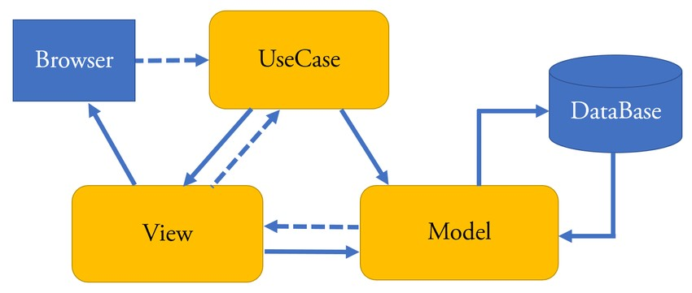
Fig 4.1 MVC Model
4.3 Detailed Description of Sub Models
4.3.1 Pre-Processing Module
- Description: Collects and validates certificate details and metadata from users.
- Functionality:
  - Accepts user inputs such as name, institution, degree, and year of graduation.
  - Validates input data to ensure accuracy and completeness.
  - Converts paper certificates into digital formats for processing.
4.3.2 Feature Extraction Module
- Description: Generates a unique cryptographic hash value for each certificate.
- Functionality:
  - Uses cryptographic algorithms (e.g., SHA-256) to generate hash values from certificate data.
  - Records the hash value on the blockchain network for immutability and transparency.
4.3.3 Classification
- Description: Converts hash values into QR codes for easy verification.
- Functionality:
  - Integrates a QR code generation library (e.g., qrcode) to create QR codes.
  - Associates the QR code with the corresponding certificate for future verification.
4.3.4 Training and Validation
- Description: Implements the verification process to validate certificate authenticity.
- Functionality:
  - Scans the QR code to extract the encoded hash value.
  - Queries the blockchain network to retrieve the recorded hash value.
  - Compares the extracted hash value with the recorded value to determine authenticity.
  - Displays the verification result to the user (authentic or tampered).
4.4 Data Flow Diagram (DFD)
4.4.1 Level 0 DFD
- Overview: Shows the interaction between users, the application, and the blockchain network.
- Components:
  - User: Submits certificate details and scans QR codes for verification.
  - Application: Processes data, generates hash values, and interacts with the blockchain.
  - Blockchain Network: Stores hash values and provides verification results.
4.4.2 Level 1 DFD
- Detailed Flow: Illustrates the steps in certificate issuance and verification.
  - Certificate Issuance: User submits certificate details → Hash value generated → Hash value stored on blockchain → QR code generated.
  - Certificate Verification: User scans QR code → Hash value extracted → Blockchain queried → Hash values compared → Verification result displayed.
4.4.3 Level 2 DFD
- Specific Steps: Breaks down the verification process into finer details.
  - QR Code Scanning: Captures QR code image → Decodes hash value.
  - Blockchain Query: Retrieves recorded hash value based on certificate details.
  - Comparison: Compares extracted and recorded hash values.
  - Result Display: Shows "Authentic" or "Tampered" based on comparison.
4.5 Sequence Diagram
- Description: Illustrates the sequence of interactions between system components during certificate issuance and verification.
- Steps:
  - User submits certificate details.
  - Application generates hash value and stores it on the blockchain.
  - Application generates a QR code for the certificate.
  - User scans the QR code for verification.
  - Application decodes the QR code and queries the blockchain.
  - Application compares hash values and displays the result.
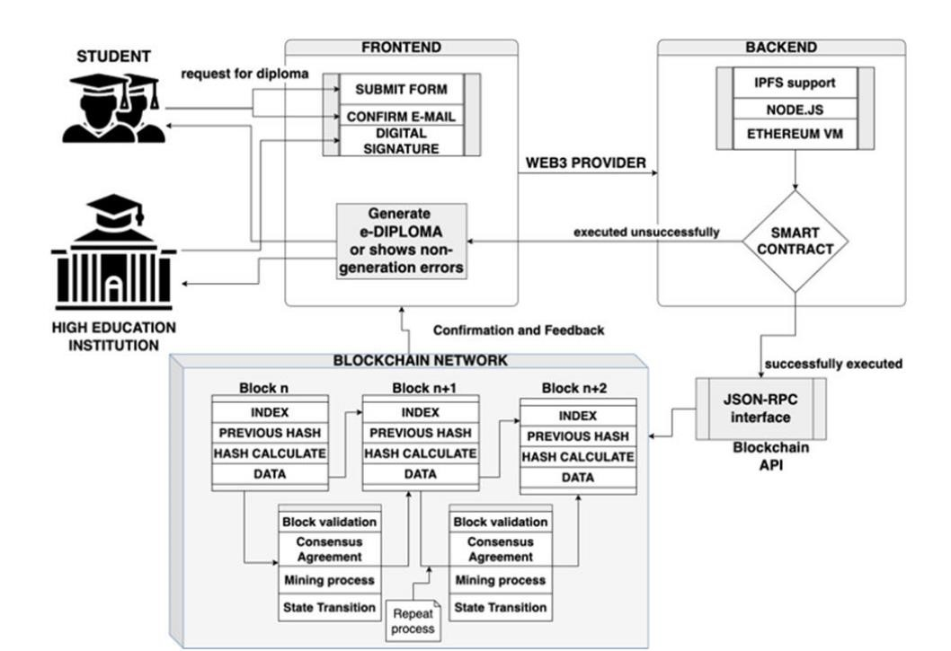
Fig 4.2 Dataflow diagram
4.6 Summary
The proposed system leverages blockchain technology and QR codes to provide a secure, transparent, and user-friendly solution for certificate verification. It addresses the limitations of traditional methods by ensuring the authenticity and integrity of digital credentials. The system is designed to be scalable, interoperable, and accessible to a wide range of users, including educational institutions, professional organizations, and regulatory bodies.

